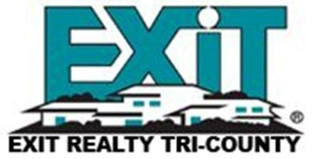
Exit Realty Tri-County Property Management Services
Free Rental Analysis:
•We photograph your property.
•Provide a list of suggestions that help market your property.
•Do a local market analysis for comparable properties
Proven Marketing:
•On the Exit Realty Tri-County website
•Yard signs are provided where allowed.
•Listed in MLS offering referrals to co-operating Realtors
Listed on 50+ web sites including
Realtor.com, Trulia, and Zillow
Tenant Occupied Properties:
•Screen every adult applicant’s credit and criminal history.
•Provide attorney prepared lease for $45.00
•Collect Rent and disperse checks to owners at the end of the month.
•Slow pay follow up
•Post notices on property for payment
•Operate within the Landlord Tenant Law
•Comply with Federal “Fair Housing Act”
•Handle repairs with licensed, insured and bonded vendors.
Owners:
•Monthly statements
•End of year statements and 1099 reporting statement.
Our job is to make you income, and to maintain the property. Please contact us for our competitive rates. You will find our services often pay for themselves; by lowering expenses, increasing occupancy rates, advanced screening techniques, resident background screening; not to mention, the savings in your time and frustration.

